

**Campus Meal Ordering System**

**CMMI 1.3 Maturity Level 2 Definition**

**By *Team Foodie***

**Lab Group: TS3**

**Date: November 2020**

**Instructors:**

**Bo An**

**Leong Yin Yoke Junie**

**Qiu Wei**

**Wang Rundong**

# SCHOOL OF COMPUTER SCIENCE AND ENGINEERING

**NANYANG TECHNOLOGICAL UNIVERSITY**

**Table of Contents**

Executive summary 3

Purpose  3

Summary of definition 3

Description 4

Level 2 KPAs 5

Requirement Management (REQM) 5

Project Planning (PP) 6

Project Monitoring and Control (PMC) 7

Process and Product Quality Assurance (PPQA) 8

Configuration Management (CM) 9

Measurement and Analysis (MA) 12

Generic goals and practices 14

Achieve Specific Goals14

Standardized processes through SDLC 14

Establish optimizing processes14

Approvals 14

CMMI audit checklist 15

CMMI interview affirmation questions 15

# 

# 

# 

# 

# 

# 

# 

# Executive summary

## Purpose

Capability Maturity Model Integration (CMMI) process model provides a clear definition of what members in a team should follow in order to achieve effective processes throughout the project lifespan. Various areas such as practices, goals, areas and models need to be defined cohesively for the CMMI process model to work effectively.

## Summary of definition

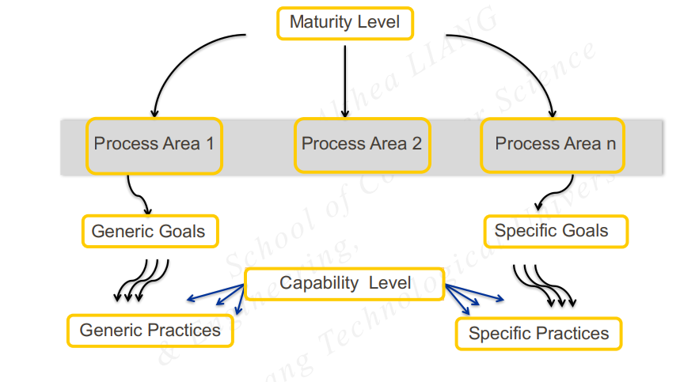

Figure 1: CMMI Level 2 Model

This following Key Process Areas (KPAs) are the requirements for CMMI Level 2

* Requirements Management
* Project Planning
* Project Monitoring and Control
* Process and Product Quality Assurance
* Configuration Management
* Measurement and Analysis

## Common Features

The following common features in CMMI are used to ensure that the Key Process Areas (KPAs) are managed, planned, performed, measured, and controlled.

* Commitment to Perform
* Ability to Perform
* Activities Performed
* Measurement and Analysis
* Verifying Implementation

# Description

At maturity level 2, the team has achieved all the specific and generic goals of the maturity level 2 process areas. In other words, the team has ensured that requirements are managed and that processes are planned, performed, measured, and controlled.

The process discipline reflected by maturity level 2 helps to ensure that existing practices are retained during times of stress. When these practices are in place, projects are performed and managed according to their documented plans. Also, the status of the work products and the delivery of services are visible to management at defined points.

Commitments are established among relevant stakeholders and are revised as needed. Work products are reviewed with stakeholders and are controlled. The work products and services satisfy their specified requirements, standards, and objectives.

# 

# 

# 

# 

# Level 2 KPAs

## Requirement Management (REQM)

**Purpose**

Managing requirements allows us to establish a common understanding between the project sponsor and the project which encapsulates the requirements stated by the project sponsor. This is the basis for planning and managing the software project.

| **Process** | **Requirement Management** |
| --- | --- |
| Entry Condition |  |
| Description | Process of defining and tweaking requirements until both ends agree the requirements that will fit the project needs |
| Exit Condition | Requirements that were agreed between the project manager and client are established |
| Begin  End | 1. Generate a list of requirements 2. Approach project sponsor for their requirements 3. Analyse requirements 4. Filter and rank requirements 5. Show project sponsor the refined requirements 6. Approval from project sponsor 7. Requirements and common ground established 8. Plan for future requirements add on |

**Goals**

1. To ensure that the requirements satisfy both the project sponsors and users

Practices

* Make agreement with the project sponsor for their requirements.
* Discuss the plan and solutions for future additions of requirements.

1. To ensure that changes in requirements can be managed with ease

Practices

* Make changes when the requirement is different or inconsistent with work.

## 

## Project Planning (PP)

**Purpose**

Project planning helps establish reasonable plans for performing the software engineering. Also, to create reasonable plans based on development realistic estimates for the work and establish necessary commitments to perform the required work.

| **Process** | **Project Planning** |
| --- | --- |
| Entry Requirement | Project Proposal  Project Description |
| Description | Project Planning includes project organisation, processes definition, project schedule, project estimation, best practices, risk process, risk management, and quality assurance. |
| Exit Criteria | Approved Project Plan |
| Begin  End | 1. Project Plan 2. Allocate roles and tasks 3. Define process structure 4. Create work breakdown structure 5. Create project schedule 6. Estimate project costs 7. Plan risk process and risk management 8. Plan project quality assurance management 9. Approval of project plan |

**Goals**

1. Create a reasonable project plan for the team to adhere.

Practices

* Plan out a reasonable project schedule in accordance to the requirements added
* Identify the risk during project development
* List hardware and software resource requirements
* Design reasonable work breakdown

1. Establish reasonable project time and cost estimation

Practices

* Establish objectives
* Breaking down the project into subtasks
* Estimating time, resources and costs to complete each task
* Identify precedence relationships and sequence activities
* Determine estimates for effort allocation

## Project Monitoring and Control (PMC)

**Purpose**

The purpose of this KPA is to ensure that the team has a clear vision on the actual project progress and knows the necessary steps to bring the software project’s performance back on track if there is a significant deviation from the software plans. It includes the tracking and reviewing of results from the software project with regards to the projected estimates and plans. According to the results obtained, plans may be adjusted.

| **Process** | **Project Monitoring and Control** |
| --- | --- |
| Entry Requirement | Project Plan  Gantt Chart |
| Description | Determine progress by comparing actual software size, effort, cost and plan schedule to the Gantt Chart |
| Exit Criteria | Actual progress is on the same track as projected progress |
| Begin  End | 1. Plan amount of time needed for each activity of the project 2. Plot all the activities on the Gantt Chart 3. Record the progress at selected milestones of the project 4. Document all the timestamps 5. Compare the documented results with expected estimates 6. Take necessary corrective actions if progress are not met |

**Goals**

1. Track actual results and progress of software project against software plans

Practices

* Establish software plans
* Document actual results

1. Adopt corrective actions when actual results and progress of software project deviates from software plans

Practices

* Use Gantt Chart to determine expected plan at selected time
* Compare with software plans to determine expected progress path
* Ensure progress is in line with software plans

## Process and Product Quality Assurance (PPQA)

**Purpose**

PPQA is to provide the project sponsors with appropriate visibility into the processes being used by the software project and the projects that are being built. This is achieved by reviewing and verifying that they comply with the applicable standards and procedures.

| **Process** | **Process and Product Quality Assurance** |
| --- | --- |
| Entry Requirement | Software Quality Assurance Plan |
| Description | Define the principle of quality assurance to ensure that quality is managed and measured, such that quality checks can be applied throughout the whole lifecycle of the development. |
| Exit Criteria | Quality of product and processes meet the quality standard set by the industry. |
| Begin  End | 1. Establish clear quality definitions 2. Establish checking processes 3. Apply all quality assurance throughout project 4. Conduct corrective actions when required 5. Document all Quality Assurance assessments and reviews 6. Review all Quality Assurance assessments to improve on processes |

**Goals**

1. Quality Assurance

Practices

* Ensure the standards of all components are in line with industry standard
* Develop the product following the defined processes
* Review the product quality after development, revert to the development stage if quality is not satisfactory

1. Quality Planning

Practices

* Select applicable standards for the application
* Define the quality of assessment process and criteria
* Apply different testing method e.g. white box testing, black box testing
* Apply unit testing, integrating testing, system testing and acceptance system when applicable.

1. Quality Control

Practices

* Define problem reporting and correction handling of the software
* Ensure team members adhere to the quality standards while developing the software.
* Document the changes to the software regarding quality correction actions

## Configuration Management (CM)

**Purpose**

The purpose is to help the team maintain the consistency, traceability and integrity of the software project during the life cycle of the project. It helps to ensure that the product delivered will be accurate and meets the stated requirements. It can be used to identify software configurations at any point in time and able to control configuration changes systemically.

| **Process** | **Configuration Management** |
| --- | --- |
| Entry Requirement | Project Plan  System Requirement Specification |
| Description | Illustrate software configuration management standard for all software configuration item |
| Exit Criteria | Document all revisions of each SCI  Define all releasable SCI |
| Begin  End | 1. Define configuration standard 2. Identify SCI in application 3. Track all SCI in application 4. Review all SCI in application 5. Make necessary changes in SCI in application 6. Document all SCI in application 7. Approve all SCI in application 8. Release all SCI in application |

**Goals**

1. Establish baseline for the project

Practices

* Identify configuration items
* Establish development baseline
* Establish testing baseline
* Establish release baseline

1. Track and review SCI

Practices

* Track request for changes
* Track revision history of SCI
* Track of status of SCI
* Track change log

1. Maintain integrity of the products

Practices

* Use configuration audit to ensure conformance of required functional and physical characteristics
* Use configuration control to manage changes

1. All releases of SCI follow configuration standards

Practices

* Review SCI before release
* Update SCI after the software configuration management standards are modified

## 

## Measurement and Analysis (MA)

**Purpose**

The purpose of MA is to provide management information necessary to implement monitoring and control of various required processes. The integration of measurement and analysis activities into the processes of the project supports the following:

* Objective planning and estimating
* Tracking actual performance versus established plans and objectives
* Identifying and resolving process-related issues
* Providing a basis for incorporating measurement into additional processes in the future

| **Process** | **Measurement and Analysis** |
| --- | --- |
| Entry Requirement | Project Plan  System Requirement Specifications |
| Description | Develop and sustain a measurement capability that is used to support management information needs |
| Exit Criteria | Document all measurements and analysis information |
| Begin  End | 1. Specifying the objectives of measurement and analysis 2. Specify measures, analysis techniques and mechanism for data collection, storage, reporting and feedback 3. Implementation of collection, storage, analysis and report 4. Provide objective results to make informed decisions and take appropriate corrective actions |

**Goals**

1. Establish measurement objectives

Practices

* Document information needs and objectives
* Document, review and update measurement objectives
* Maintain traceability to the identified information needs and objectives
* Provide feedback for refining and clarifying information needs and objectives as necessary

1. Specify measures and collect measurement data

Practices

* Identify measures based on documented measurement objectives
* Specify operational definitions for the measures
* Prioritise, review and update measures
* Obtain data for base measures
* Generate data for derived measures
* Perform data integrity checks as close to the source of the data as possible

1. Analysis measurement data

Practices

* Conduct analyse, interpret the results, and draw preliminary conclusions
* Refine criteria for future analyses

1. Communicate Results

Practices

* Keep relevant stakeholders apprised of measurement results on a timely basis
* Assist relevant stakeholders in understanding the results

# Generic goals and practices

## Achieve Specific Goals

* Perform specific practices as listed above

## Standardized processes throughout SDLC

* Establish organizational-wide policy
* Provide resources

### Assign responsibility

* Identify and involve relevant stakeholders
* Monitor and control process
* Objectively evaluate adherence

1. Establish optimising processes

* Ensure continuous process improvement
* Correct root causes of problems

# Approvals

# 

| **Role** | **Personnel** | **Status** |
| --- | --- | --- |
| Project Manager | Ma Xiao | Approved |
| Quality Assurance Manager | Jun Yi | Approved |
| Project Sponsors |  |  |

# 

# Glossary

| **Acronym** | **Definition** |
| --- | --- |
| SCI | Software Configuration Item |
| SDLC | Software Development Life Cycle |

# 

# CMMI audit checklist

| **Level** | **Name** | **Abbreviation** | **Process Area** |
| --- | --- | --- | --- |
| 2 | Requirement Management | REQM | Project Management |
| 2 | Project Planning | PP | Project Management |
| 2 | Project Monitoring and Control | PMC | Project Management |
| 2 | Process and Product Quality | PPQA | Support |
| 2 | Configuration Management | CM | Support |
| 2 | Measurement and Analysis | MA | Support |

# CMMI interview affirmation questions

The following are some of the interview questions used to help define CMMI1.3 Level 2:

* Explain what is CMMI Level 2: Managed?
* Explain the SCAMPI Process
* Explain Project Management concepts
* What to include in CMMI Level 2 Documents